Guess my recipe (Pizza )

Part 1 Mix and match with words from recipe
Ham | skinke
Onions | løg
Basil | basilikum
Flour | mel
Yeast | gær
Water | vand

floured | melet/mel på bord
fingertips | fingerspidser
Repeat | gentag
sprinkle | drys
toppings | fyld/pynt
crust | sprød

Dough | dej
Smooth | glat
Hours | timer
Divide | del /når man deler noget
slightly | let/lidt
working outwards | arbejde udad

Part 2 Guess my recipe from ingredients
Water,yeast, flour, olive oil, salt, sugar, Tomato sauce, Mozzarella cheese, peppers, Italian sausage, basil, Pesto, Pepperoni, Onions, Ham.

Part 3 read the recipe

Making the Pizza Dough
Mix water and yeast in a bowl.
Mix in the flour, salt, sugar, and olive oil.
Knead the pizza dough until the dough is smooth and elastic.
Cover the dough and let sit in a warm place (75-85°F) until it doubles in size, at least 1 to 1 1/2 hours.
Divide the dough in half.
Take one ball of dough and flatten it with your hands on a slightly floured table. Starting at the center and working outwards, use your fingertips to press the dough.
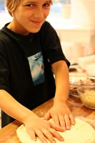
Repeat with the second ball of dough.
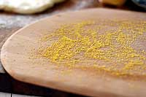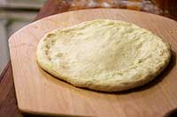

Put on the tomato sauce, sprinkle with cheese, and place your toppings on the pizza.
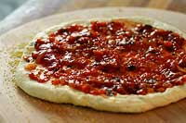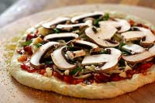
Bake pizza until the crust is browned and the cheese is golden, about 10-15 minutes. If you want, toward the end of the cooking time you can sprinkle on a little more cheese.
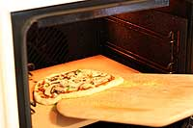

Glossary
Water (vand) Yeast (gær) Flour (mel) Olive oil (oliven olie) Salt (salt), Sugar (sukker) Tomato sauce (tomat sovs) Mozzarella cheese(mozzarella ost) Basil (basilikum) Onions (løg) Ham (skinke) Bowl (skål) Dough (dej) Smooth (glat) Hours (timer) Divide (del /når man deler noget) slightly (let/lidt) floured (melet/mel på bord) working outwards (arbejde udad) fingertips(fingerspidser) Repeat(gentag) sprinkle (drys) toppings (fyld/pynt) crust (sprød)
golden (gylden) toward (hen imod)

Part 4 put the recipe back together

Making the Pizza Dough
Bake pizza until the crust is browned and the cheese is golden, about 10-15 minutes. If you want, toward the end of the cooking time you can sprinkle on a little more cheese.

Mix water and yeast in a bowl.

Divide the dough in half.

Take one ball of dough and flatten it with your hands on a slightly floured table. Starting at the center and working outwards, use your fingertips to press the dough.

Repeat with the second ball of dough.

Mix in the flour, salt, sugar, and olive oil.

Knead the pizza dough until the dough is smooth and elastic.

Put on the tomato sauce, sprinkle with cheese, and place your toppings on the pizza.

Cover the dough and let sit in a warm place (75-85°F) until it doubles in size, at least 1 to 1 1/2 hours.

